Howard Gardner, Epstein and the pandemic

“I told JE explicitly that I could not and would not accept any further support from him,” Howard Gardner, a Harvard University specialist in cognitive science and education who thanked Epstein in a 2005 book for research support and “valued friendship,” told BuzzFeed News by email.
https://www.dnb.com/business-directory/company-profiles.howard_gardner_community_charter_school.c1b471f90e101dacf9db82ba2e6c70e5.html

Howard Gardner on twitter: Home education during the pandemic:
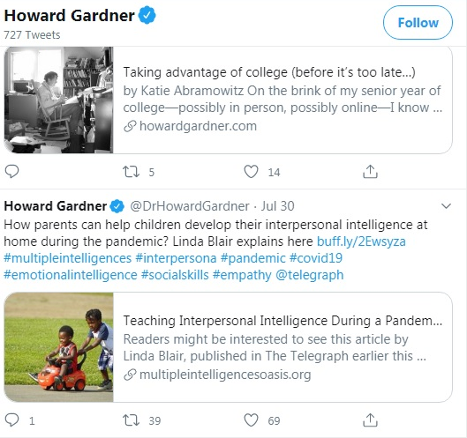

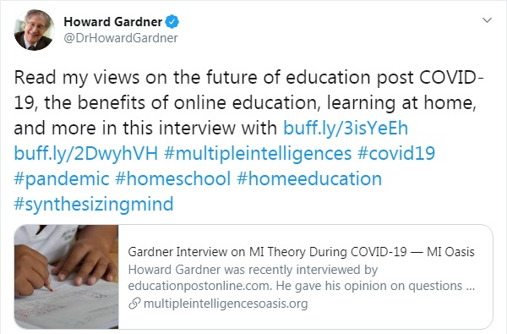

Howard Gardner responds to question about existential intelligence during the covid-19 crisis:
An undergraduate student from Long Island, New York, recently wrote asking the following question.
I was hoping you would be able to provide some insight on the “Frame of Mind” of people in quarantine from Coronavirus. Since there has been a dynamic shift in our perception of reality due to fear, do you believe that while people are isolated in quarantine Existential Intelligence is ever more present in children?
Schools aren't exactly teaching existentialism but the classroom that exists beyond a physical space is now as prominent as ever. Kierkegaard's notion of angst may have relevance here. Children desire structure and routine in school to reduce anxiety in the classroom, now only to be uprooted by the unknown. Children are left to ask, "Why?"
Howard Gardner responds:
I think that's a very reasonable assumption. A lot depends on two factors:
- How the adults (and the media) deal with COVID-19. When children get a clear and unambiguous signal from their parents and other respected adults, they are likely to accept the situation. On the other hand, when they sense that their parents are not on the same page, watch out!
- Whether the children listen carefully to the answers to their questions and wrestle with them. I've often quipped that all children that I know like to ask questions—but children differ in whether the asking is the point, or whether they also deal with and follow up on the responses that they receive.
https://www.multipleintelligencesoasis.org/blog/2020/4/2/howard-gardner-responds-to-question-about-existential-intelligence-during-the-covid-19-crisis
Howard Gardner: Towards Collective Well-Being: https://www.oecd.org/education/2030-project/teaching-and-learning/learning/learning-compass-2030/
The Howard Gardner Community Charter School: https://www.hgcschool.org/apps/pages/index.jsp?uREC_ID=506523&type=d&pREC_ID=1030684
And here: https://www.greatschools.org/california/chula-vista/25541-Howard-Gardner-Community-Charter/

